<https://argo-cd.readthedocs.io/en/stable/>

minikube start --vm-driver=virtualbox

kubectl create namespace argocd

kubectl apply -n argocd -f <https://raw.githubusercontent.com/argoproj/argo-cd/stable/manifests/install.yaml>

Edit the argocd server and change the type to nodeport:



minikube service list -n argocd

TO create a tunnel and provide an IP address to login to argocd run the below command:

minikube service argocd-server -n argocd

Use the IP and browse:

Username: admin

Password : Get from secrets

Edit the initial secret and get the password and decrypt it since it is in encrypted format:



For sample apps using argocd use the below repo:

<https://github.com/argoproj/argocd-example-apps>

Application Name must be lowercase

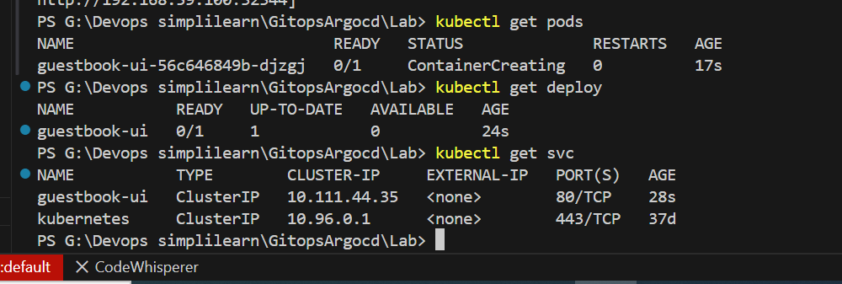

Change the svc type to NodePort and browse:

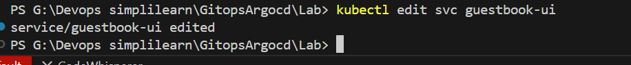

Now change the replica in github and commit the changes :

Now when I manually change the configuration of cluster/resources manually, without committing in git:

Changed the replica to 3

Its showing as out of sync and in the next sync it will automatically sync with the git and make the replica to 1:

Make sure the self heal and self prune options are enabled within automatic sync then only it will heal itself.

